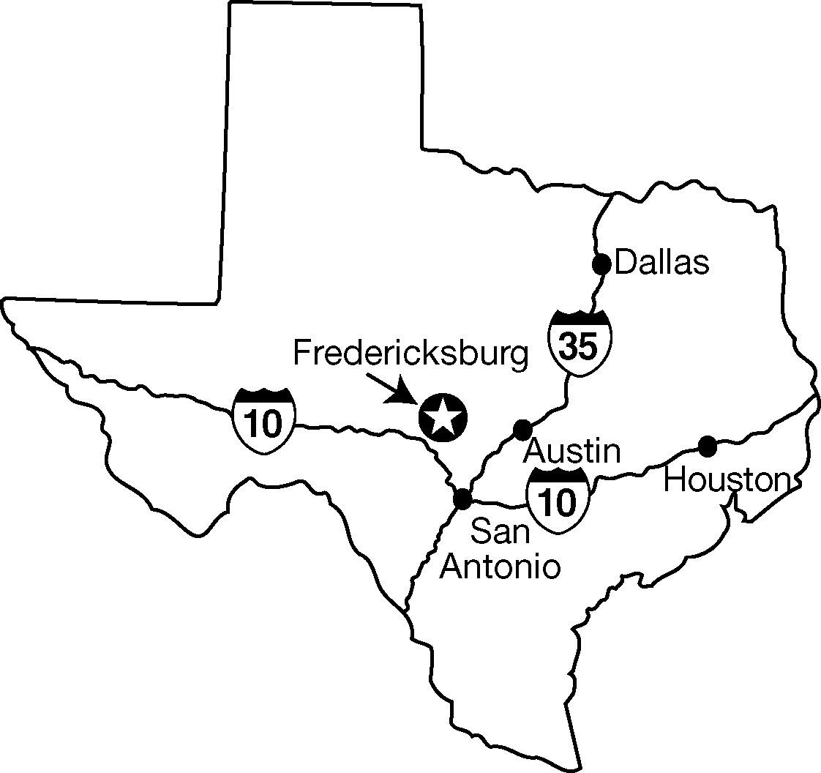

GGillespie County, County Seat: Fredericksburg

City of Fredericksburg, County of Gillespie, State of Texas, located 75 miles West of Austin, 65 miles Northwest of San Antonio, 260 miles Southwest of Dallas

POPULATION

*estimate
 | 1980 | 1990 | 2000 | 2023
City | 6,412 | 6,934 | 8,911 | 11,760*
County | 13,532 | 17,204 | 20,814 | 27,570*

INCENTIVES

Tax Abatement | Considered
Enterprise Zone | No
Industrial Foundation | Yes
Reinvestment Zone | No
Other: Texas Econ. Dev. Council., SBA, UTSA Small Business Dev.

TRANSPORTATION

AIR SERVICE
Nearest Airport | Gillespie County Airport
Runway Length | 5,001 ft.
Runway Surface | Asphalt
Weight Capacity | 30,000 lbs. single wheel
Lighted | Yes
Fuel | AvGas and Jet Fuel 24 hour
Instrument Approaches | L-NAV Runway 14
GPS LPV Runway 32
AIRPORTS NEARBY
Commercial Service | San Antonio International
 | Austin-Bergstrom
General Aviation | Kerrville

HIGHWAY SERVICE:
U.S. Highway 290  U.S. Highway 87  Texas Highway 16 | Interstate 10 – 22 miles southwest on Highway 16; 23 miles south on Highway 87

FREIGHT CARRIERS
Interstate and intrastate carriers, overnight courier service:
UPS, Federal Express, U.S. Postal Service

PROPERTY TAX

TAX RATE (PER $100 ASSESSED VALUE) – 2023
Gillespie County | $0.2796
Fredericksburg, City | $0.16518
Fredericksburg ISD | $0.7754
HCUWCD/WCID | $0.004876
Stonewall WCID | $0.3113
Harper ISD | $0.6692
Doss CCSD | $0.6692
SALES TAX

Fredericksburg
Municipal Sales Tax | 1-1/2%
State Sales Tax | 6-1/4%
Econ. Dev. Sales Tax | 0%
Other Sales Taxes | 1/2%

WAGE DATA

Source: Texas LMI TRACER; data from 1st Quarter 2023

OCCUPATION | AVG WAGE
All Industries | $933.00
Construction | $1093.00
Agriculture, Forestry, Fishing & Hunting | $842.00
Mining | $976.00
Manufacturing | $879.00
Retail Trade | $706.00
Wholesale Trade | $1086.00
Transportation and Warehousing | $913.00
Information | $1292.00
Finance and Insurance | $1790.00
Real Estate and Rental and Leasing | $874.00
Professional and Technical Services | $1248.00
Administrative and Waste Services | $1029.00
Educational Services | $853.00
Health Care and Social Assistance | $1175.00
Arts, Entertainment and Recreation | $785.00
Accommodation and Food Service | $571.00
Public Administration (local government) | $1211.00

CITY GOVERNMENT

Type | City Council (Home Rule)
Number on Council | 5
Municipal Police | 38
Paid Firemen/EMS | 32
Volunteers | 45
City Zoning Body | Yes
Master Plan | Yes, January 2006

UTILITIES

ELECTRIC POWER: | City of Fredericksburg; Central Texas Electric Co-op
Reliability | 99+%
Total Capacity | 140 MW
Reserve at System Peak | 35%
Transmission Voltage | 138,000 volts
Service Voltage | 110/220, 120/208 277/480, 480
NATURAL GAS | Atmos Energy
BTU Content Per Cubic Foot | 1,100
TELEPHONE SERVICE | Frontier
Digital | Yes
Analog | Yes
Electromechanical
Make and Model
Software Level
Fiber Optics | Yes
Switched 56 KBPS | Yes
High Capacity Digital (T-1) | Yes
Digital Data Service | Yes
911 | Yes
Other Network Services: All major services

WATER SUPPLIER |  | City of Fredericksburg
Source |  | Ground Water
Max. System Capacity (daily: |  | 7,000,000 gallons
Max. Daily Use To Date |  | 5,000,000 gallons
Pressure on Mains |  | 35-125 PSI
Storage Capacity |  | 5,000,000 gallons
Size of Mains |  | 2”-20”
System Looped |  | Yes
SEWER SYSTEM
Type Treatment Plant |  | Activated Sludge
Maximum Capacity |  | 2,500,000 gallons
Max. Daily Use To Date |  | 1,500,000 gallons

EDUCATION

FREDERICKSBURG ISD
Public School Budget |  | $ 61,762,681
 | Schools |  |  | Enrollment
Primary School | 1 |  |  | 453
Elementary School | 1 |  |  | 708
Middle School | 1 |  |  | 634
High School | 1 |  |  | 1026
Stonewall Elementary | 1 |  |  | 111
Harper ISD | 1 |  |  | 611
Doss CCSD | 1 |  |  | 24
PRIVATE SCHOOLS | 3 |  |  | 739
AREA UNIVERSITIES/COLLEGES
Hill Country University Center, a Multi-Institution Teaching Center offering collaborative programs with Central Texas College and Texas Tech University
Industrial Job Training |  |  | Yes
Vocational Program |  |  | Yes

COMMUNITY INFORMATION

HEALTH CARE
Total Hospital Beds in City | 83
Total Doctors (medical) in City | 64

MEDIA
Newspaper | Fredericksburg Standard
Radio Stations | 4 (AM-FM)
TV Stations/TV Cable | Spectrum
CHURCHES
Catholic - 4
Protestant - 46

COMMUNITY INFORMATION (cont’d)

RECREATION
Parks | 6
Museums | 3
Historic Sites | 7
Health Centers | 3
Public Golf Courses | 1
Tennis Courts | 18
Bed & Breakfast Rooms | 1,956
Hotel & Motel Rooms | 1,186
Libraries | 2
RV Parks/Campgrounds 13
Community Theater , Community Chorale (Adult & Children), Community Art Guild, Community Bands

AREA ATTRACTIONS
LBJ State and National Park, National Museum of the Pacific War, Enchanted Rock State Park, Pioneer Museum, Fort
Martin Scott, Lady Bird Park and Golf Course,
Luckenbach, Wildseed Farms, 70+ Wineries,
Rock Box Theater

CLIMATE
Annual Average Temperature | 66 F
Average High Temp. Summer | 92 F
Average Low Temp Winter | 31 F
Annual Average Precipitation | 28.7”
Annual Average Snowfall | Trace
Elevation | 1,742’

FINANCE: Total Deposits $1,577,722 (Jun 2023)
Arrowhead Bank, Texas Regional Bank, Broadway Bank, Chase Bank NA, PNC Bank, First United Bank, Security State Bank, Centennial Bank, Woodforest National Bank, Guadalupe Bank, Prosperity Bank, Texas Partners Bank.

MAJOR AREA EMPLOYERS

EMPLOYER | PRODUCT | EMPLOYEES
Hill Country Memorial Hospital | Health care | 619
Fredericksburg Independent School District | Public education | 480
H.E.B Food Store | Retail grocery | 230
Wal-Mart | Retail | 220
City of Fredericksburg | Government | 193
Knopp Nursing/Retirement Homes | Health care/nursing | 185
Gillespie County | Government | 185
Side Street Hospitality | Restaurants/Lodging | 143
Security State Bank | Banking/Finance | 138
Boot Ranch | Resort | 136
Allen Keller Company | Heavy construction | 135
Grape Creek Vineyards | Wineries | 135
Fredericksburg Enterprises | Lodging | 104
Elements Hospitality | Restaurants/Lodging | 104
Harper Independent School District | Public education | 95
Fischer & Wieser Foods | Specialty foods | 93
Central Texas Electric Cooperative | Electric utility | 90
Becker Vineyards | Winery | 64
Opa’s Smoked Meats | Wholesale meats | 60
Mamacita’s | Restaurant | 60

